ANNUAL
RUN WITH COURAGE 5K
Saturday, April 15, 2023
to benefit

Judi’s Place for Kids

- A Bright Solution to Child Abuse for
Pike, Floyd, Johnson, Martin, and Magoffin Counties

Sponsor Packages
Event Director
Kalen Richmond
Cell: 812.361.3185
Kalen.Richmond@ky.gov
www.judisplace.org

www.facebook.com/JudisPlace4Kids
www.runsignup.com/runwithcourage
Instagram: @judisplace

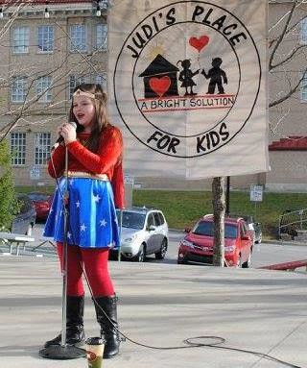
Judi’s Place for Kids by the numbers:
- 2 Locations
- A nationally accredited program
- More than 400 children served in 2022
- 8 full-time and 4 part-time staff
- 3 physicians and one trauma therapist
- Dozens of trained community partners
- Thousands reached through community awareness and media

Run with Courage!
The idea for this race came from a young mother in our community who was disturbed by the story of a young child who died from abuse. She wanted to do something to help end child abuse. Over the years, the race has grown into the Run with Courage, held in April with a superhero theme and hundreds of participants!

With your help, through its nationally accredited children’s advocacy center, Judi’s Place for Kids works to prevent and end child abuse in Pike, Floyd, Johnson, Martin, and Magoffin Counties.

Why is the race “Run with Courage” and why a superhero theme? Because it takes courage for children to talk about the abuse they are experiencing, and it takes courage for caring adults to report abuse. It also takes a team of everyday superheroes to help children and their caregivers get on a path to healing. We consider all of these workers superheroes:
- Law enforcement officers
- Child protection workers
- Prosecutors
- Forensic interviewers
- Medical personnel
- Victim advocates.
But we honor most of all the courage of the survivors, the children who share their stories with us. When you support the Run with Courage, you let these children know that they are not alone!

Please take a moment to consider the available sponsorship packages. Your support ensures a successful event and helps Judi’s Place for Kids continue as a bright solution for abused children.

All sponsors will receive a certificate to display to let your customers know that you care about the children of our community. We will also provide flyers and print brochures to encourage your employees and customers to register. Groups and businesses will be recognized at the event for their number of participants and total funds raised.

Thank you for caring about the children in our community!

About the Race
The Run with Courage is not only a race for runners. In addition to the 5K Route, there is also a 1-mile fun walk option and a kids’ fun run after the event. We will also honor some of the everyday heroes in our community during the awards ceremony through the One with Courage awards. We will have a costume contest and will also be coordinating with Pikeville DPP as they host Kids Day in the Park upon the conclusion of the awards ceremony. It is truly a family-friendly event for the whole community.

This year’s event is Saturday, April 15, 2023 and begins at 9 a.m. Registration starts at 7 a.m.
at the Pikeville City Park.

CHIP TIMING AND ONLINE REGISTRATION
This year’s event features professional chip timing by Appalachian Timing Group. Online registration for sponsors and teams is streamlined this year through runsignup.com/runwithcourage

T-SHIRTS
Pre-registration and taking advantage of group discounts is highly encouraged. Participants registered by March 24 are guaranteed a T-shirt in their size. Only a limited number of additional T-shirts will be ordered. Finisher medals will be provided for 5K completion again this year.

SUPERHEROES - SPIRIT OF THE RACE
We encourage everyone at the race to DRESS AS YOUR FAVORITE SUPERHERO! When you help children, YOU are a superhero!

This year, race participants will be encouraged to utilize online peer-to-peer fundraising to generate additional funds. These funds enable us to provide specialized services provided by professionals and trained volunteers who make an impact in the lives of hundreds of children. It is easy to raise additional funds through runsignup.com.

YOUR SUPPORT MAKES THE DIFFERENCE!
While we can’t share the exact stories of the children, we can share what their caregivers say
about what they appreciated the most about Judi’s Place for Kids in 2022.
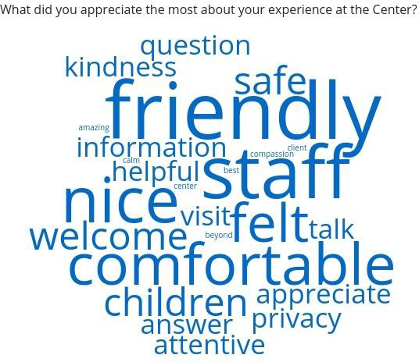

REGISTRATION OPTIONS
1.) We will also be able to set up a special code for sponsors through runsignup.com/runwithcourage to make it easy for sponsors to register their team! Or sponsors can return registration forms for complimentary entries to Kalen.Richmond@ky.gov. A discount code will be provided for additional entries if additional paid entries are desired. The group discount will apply. Registration forms can be downloaded and printed from www.judisplace.org/courage

2.) Print and mail or drop off registration. Fill out a print registration form and mail with payment to Judi's Place for Kids, 128 S. College Street, Pikeville, KY 41501. Print forms are available at www.judisplace.org/courage in pdf format. Call us for print registration forms to be mailed or brought to you.

FREQUENTLY ASKED QUESTIONS

Can I walk the 5K?
Participants are welcome to walk the 5K course! We encourage participants to train and work to finish the 5K in no more than 1 hour and 15 minutes if possible. Please call with any questions. What about strollers?
Strollers are welcome! We have a separate stroller category for the 5K.

What is the race course?
See map below. We will have volunteers and signs at each turn.

Where should I park?
We are expecting a big crowd so we encourage use of the parking garage.

Where do I register or pick up my bag?
Registration and packet pick up for pre-registrants will be near the Garfield House on College Street. There will be separate tables for same-day registration and packet pick-up. We ask everyone to come early and sign in. Registration opens at 7 AM and closes at 8:45 AM! We will e-mail participants if we have a location before the event for packet pick up.
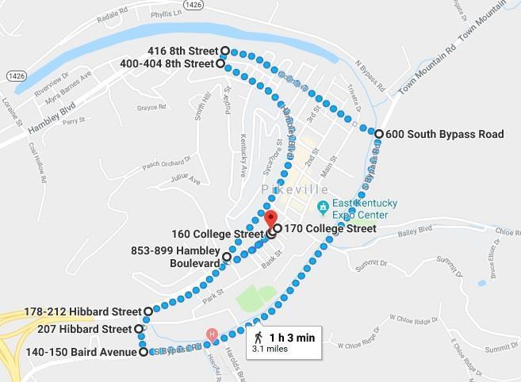

2023 Run with Courage Sponsorship Opportunities

Donation Level | Platinum  $1,500 | Gold  $750 | Silver  $400 | Bronze  $150
Spots Available | 6 | 8 | 12 | Unlimited
Large logo on shirt (4”x2”)* | X
Medium logo on shirt (3”x1.5”)* |  | X
Small logo on shirt (2”x1”)* |  |  | X
Name on shirt |  |  |  | X
Large logo on event website & Judisplace.org | X
Medium logo on event website & Judisplace.org |  | X
Small logo on event website & judisplace.org |  |  | X
Name on event website & judisplace.org |  |  |  | X
Large logo on banner at office and event | X
Medium logo on banner at office and event |  | X
Small logo on banner at office and event |  |  | X
Name on banner at office and event |  |  |  | X
Table at event for marketing items | X
Complimentary race entries (used at sponsor’s discretion). Additional entries at group rate. | 15 ($450 value) | 8 ($240 value) | 4 ($120 value) | 2 ($60 value)
Mention in paid event advertising | X | X
*T-shirt logo sizes based on standard medium size shirt, other sizes may have minor adjustments
Run with Courage 2023 Event Sponsorship Form

Sponsorship Deadline: March 24, 2023

Email to Kalen.Richmond@ky.gov
Mail to Judi’s Place for Kids, 128 S. College St., Pikeville, KY 41501
Or Fax to 606.432.0508
Yes! Sign me up as a sponsor! Sponsorship Level (Circle One)
*Platinum $1,500 *Gold $750 *Silver $400 Bronze $150 Business Name (as it should appear in all event materials):

Contact Name:

Telephone:

Email:

* Platinum, Gold, and Silver levels, please email your logo to Kalen.Richmond@ky.gov

Make checks payable to
Please call 606.437.7447
with any questions.
Judi’s Place for Kids 128 S. College Street Pikeville, KY 41501

If you want to pay by credit card, please contact Kalen for details. There are processing fees.
Tax ID#: 61-1366084
Judi’s Place for Kids is a bright solution for abused children – a community working together to promote safety and justice, offering hope and healing so that all may thrive and reach their full potential. Contributions are tax-deductible to the extent of the law.

